

Tree Removal

Date notice affixed: Date Month Year

Lambeth Council

Propose to remove this tree and are running an open consultation period of 28 days beginning 23/02/2026
Following investigations as part of Lambeth council’s normal tree management practices, the Field Maple tree at 38 Holmewood Gardens has been conclusively implicated in subsidence related damage to property and regretfully, we have concluded that it must be removed to prevent further damage.

Should you require information or wish to register your opinion regarding the proposed felling, please contact the Tree Service at Lambeth council quoting DTC35510

trees@lambeth.gov.uk or 0207 926 1000
Kennington Park Depot, St. Agnes Place, Kennington, SE11 4BE
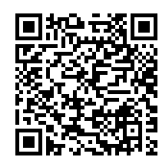
Submit comments in the consultation online
Scan the QR code to take a look at our Tree Management Policy
https://www.lambeth.gov.uk/planning-building-control/trees

